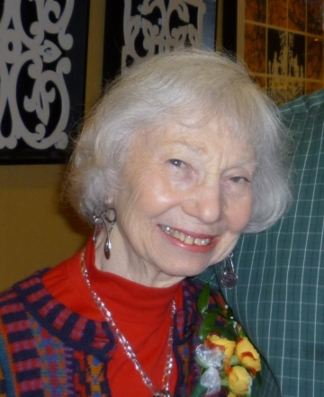
June Moss Handler
1923 - 2017

June Moss Handler, 94, died on November 6, 2017 at her home in Hackensack, NJ of pancreatic cancer. She was with family members, daughter Roberta Polton and son Peter Handler. June was Professor Emeritus of Early Childhood Education at Kean University in New Jersey and was active in a wide array of activities and organizations committed to infants and toddlers. She also participated in groups that reach across the social and economic barriers of our society. June was born in Brooklyn, NY in 1923 to Grace and Maximilian Moss. Her father, Maximilian Moss, was a distinguished attorney, community leader and Surrogate of Kings County. June attended James Madison High School and graduated from Pembroke College, Brown University in 1943 as an English Major. Her love of poetry, nurtured while an undergraduate, was a source of joy throughout her life. She married Morton D. Handler in 1947 in Brooklyn. Shortly thereafter, the young couple moved to Teaneck, New Jersey where they became active participants in community activities and raised Peter and Bobbie.

June became increasingly interested in child development and studied at Bank Street College in the early 1950s. She subsequently went on to earn a doctorate in education at Teachers College Columbia University in 1965. June was committed to the Civil Rights movement and her academic research focused on the impact of prejudice and ways to counteract it. This was more than an academic exercise. When June noticed that the crayon color flesh did not address the real world range of skin tones, she contacted the crayon manufacturer, saying “flesh comes in many colors.” The crayon color was renamed “peach.” June was later honored for her efforts.

She began teaching at what was then Newark State College, which became Kean University.

After the 1967 Riots in Newark, June was invited to meet with a grassroots coalition of low income parents with limited access to child care. Together they developed an innovative infant and toddler program called Babyland. June would openly say it was on the job training for all involved, including her - there simply were no models for what they ultimately succeeded in doing. June fought the notion that this was a babysitting service and developed the staff and curriculum that focused on teaching young children. The program was successful and educators from around New Jersey began reaching out to learn from her experience. June, along with her graduate students, founded the Coalition of Infant/Toddler Educators and helped develop and implement New Jersey's regulations for infant care centers with regulations and requirements that became national models. Many were adopted around the country. June led the State's efforts in Head Start and spent hours traveling to Trenton where she developed meaningful programs to benefit the State's youngest and most vulnerable children. Throughout this all, she was a devoted wife to Morton. They enjoyed a wide circle of friends, an active social life and spent summers at the Farm in Putnam County with the Moss family. As Mort's health deteriorated, June retired from Kean to take a more active role in his care. She was attentive and effective and, in spite of Mort's physical limitations, they traveled, maintained family obligations and enjoyed a wide range of cultural activities. After Mort's death, June remained active with friends and family. She established a wonderful relationship with Boris Bierstein, an acquaintance from Temple Emeth in Teaneck, and the couple had several fulfilling years of travel and companionship with the support of their children. In later life June never lost her trademark modus operandi: If you see a problem, you must do more than complain. You must act. An example was her concern about the growing divide between different religious communities in Bergen County. June was a founder of a group of Bergen County Jewish, Christian and Muslim women who met, talked and studied together for almost a decade. The dialogue has resulted in better understanding among communities and fostered many new relationships. June took enormous pride in her participation in the group. She found a new set of friends whom she absolutely treasured.

June was committed to poetry. She would spend hours working on a new work, writing and rewriting, struggling to find the right word or phrase. Her group at the Whitehall (her residence building) added another level of engagement and meaning.

June was a fully engaged mother, grandmother and great grandmother and played a major role in the lives and families of Maya, Maddy, Rachael, Gabby and Isaac. She loved them and let them know it. And she appreciated that she got to know her four great grandchildren: Jake, Henry, Sadie and Emma. June also leaves her sister, Beverly Moss Spatt of Brooklyn Heights, NY; her sister-in-law, Hope Handler Punnett of Philadelphia; her son-in-law, Richard Polton and daughter-in- law, Karen Singer, as well as cousins, nieces, nephews, grand nieces and nephews and numerous friends of long standing.

