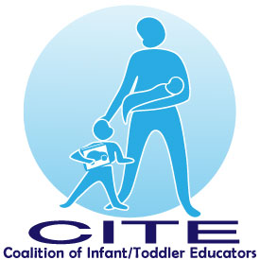
University Chapter Fall Workshop Series
TITLE: Introduction to HighScope for Infants & Toddlers, Part 1
DATE: Wednesday, October 25, 2017
PLACE: ECYC – East Grand Avenue, Rahway, NJ
TIME: Registration 6:30 pm (no admittance to the building until 6:30 pm)
Workshop 7:00 pm – 9:00 pm

COST: Members $5.00 (CITE members will have their check returned at the workshop)
Non-members $10.00

PRESENTER: Valeria Erdosi-Mehaffey, Executive Director, King’s Daughters Day School
------------------------------------------------------------------------------------------------------------------------------------------Registration Form
Name: _____________________________________________________________________________
Daytime telephone: _________________________Cell phone:_________________________________
Mailing Address: _______________________________________________________________________
e-mail: _______________________________________________________________________________
Employer: ____________________________________________________________________________
Address: _____________________________________________________________________________
Please return the registration form by October 20 with a check payable to: CITE University Chapter
Mail to: Kathie Meyer 2042 Brookdale Park Drive Forked River, NJ 08731
No refunds. Space is limited. For questions call Kathie (609) 713-5722 or Kathie2042@comcast.net
Phone on night of workshop (732) 594-3292

