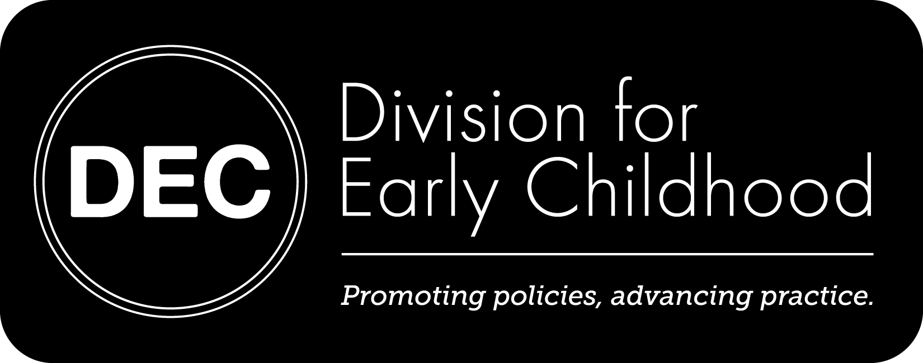

**DEC CONTACT INFORMATION**

**P** 310-428-7209

**E** dec@dec-sped.org

www.dec-sped.org

Two Day Strands

May 1 and May 2

**Embedded Instruction:**

**Doing What Comes Naturally**

*Patricia Snyder& Barbara Wolfe*

Embedded instruction is an approach that promotes engagement and learning in everyday activities, routines, and transitions for young children. Participants in this 2 day strand will explore ways to plan, implement and evaluate embedded learning opportunities that maximize children’s motivation, follow their interests, and promote generalization and maintenance within and across activities, routines, and transitions.

**Intersecting Interests:**

**The Story Plus the Snuggle**

*Lise Fox and Carol Trivette*

Drawing on evidence-based practices this 2 day strand will highlight strategies and resources for promoting simultaneous attention to literacy and social emotional development for children, birth to five years of age, with identified disabilities, developmental delays, or at-risk for poor outcomes. Presenters will introduce key concepts, provide illustrations, and support opportunities for practice, evaluation, and reflection, enabling participants to apply new practices in the work they do every day.

Pre-registration is required to participate in the 2 day strands.

**Hotel Accommodations**

Hilton Burlington Hotel

60 Battery Street

Burlington, VT 05401

To get the discounted room rate of $149, please call 802-659-6500 before April 4th. You must indicate that you are with the Division for Early Childhood to get the discounted rate.

New Possibilities:

Using Evidence-Based Practices that Support Inclusion

May 1 – May 2, 2014

Burlington, VT

Institute Schedule



*New Possibilities is a two-day professional development institute designed to strengthen the daily practices used by professionals in the field of early childhood special education.*

Several frameworks will guide New Possibilities:

* **New formats** for learning drawn from the evidence-based resources on professional development and adult learning. Participants will have the opportunity to design their own professional development experience. Time will be built in to connect with a network of talented professionals, including presenters from across the country.
* **New content that has not previously been presented anywhere**
* DEC’s updated **Recommended Practices** will serve as the foundation for the New Possibilities

New Possibilities Program Format

The two day institute includes *2 day strands*, two *1 day strands,* and *open sessions*. Both 2 day strands and 1 day strands require pre-registration. If you are pre-registering for a strand, you will be expected to attend all segments of the strand in its entirety. Institute attendees will be able to select among open sessions upon arrival.

**Open Sessions: May 1 & May 2**

*Sessions will be facilitated by experts from a variety of national, state, and local contexts.*

During New Possibilities, participants will be able to participate in open sessions on a variety of topics ranging in length from 90 minutes to 3 hours.

Currently scheduled session topics include:

* Working with interpreters, translators, and cultural mediators
* Fabulous and free: Resources to support your work
* Authentic collaboration with diverse families
* Field trip to inclusive early childhood programs
* Supporting infants and toddlers who are dual language learners (DLLs)
* Using iPads for documentation, collaboration, and celebration
* Supporting preschoolers who are dual language learners (DLLs)
* Designing play spaces that work for all children
* Additional open sessions will be added based on the content priorities of participants.

Registration

Members: $200

Nonmembers: $300

Early Bird Discount before Jan. 1:

Members: $185

Nonmembers: $275

One Day Strands: May 1 and May 2

**Environments and Interactions That Support Infants and Toddlers**

*Tweety Yates*

Interested in the latest information on evidence-based practices that support infants and toddlers? Participants in this 1 day strand will leave with a thorough understanding of practices that can enhance the social emotional competence of infants and toddlers with emphasis on intentional interactions and relationships with their caregivers in home, program, and community settings. This session will build upon evidence-based practices from several national projects including *Parents Interacting With Infants (PIWI)* and the Center on the Social and Emotional Foundations for Early Learning (CSEFEL).

**Universal by Design: Inclusive Approaches that Support Each Preschool Child**

*Eva Horn*

Early educators face the challenge of planning for and implementing learning activities that are interesting, engaging, and relevant to a range of young learners while addressing critical early learning outcomes. This 1 day strand will feature a practical, evidence-based framework designed to serve as a guide for early educators as they plan and implement a universally designed, challenging curriculum that supports each child's school success. Specific developmentally appropriate strategies for providing challenging universally designed curriculum content, differentiation through curricular modifications, individualization (strategies and plans for supporting children’s unique learning outcomes), and child progress monitoring procedures will be provided.

Pre-registration is required to attend a 1 day strand. If you choose a 1 day strand, you will be able to attend open sessions of your choice on the other day or an additional 1 day strand.

Additional Information

Conference registration includes the following:

* Complimentary participation in all instructional sessions
* Complimentary breakfasts on May 1 & May 2
* Networking Reception on May 1
* Coffee Breaks

